**J.N.T.U.H. UNIVERSITY COLLEGE OF ENGINEERING, SCIENCE AND TECHNOLOGY HYDERABAD**

**KUKATPALLY, HYDERABAD – 500085**



**CERTIFICATE**

This is to certify that **REYA STALIN JOSEPH** of B.Tech IV year I Semester bearing the Hall-Ticket number **21011A0569** has fulfilled his/her DATA ANALYTICS LAB record for the academic year 2024-2025.

Signature of the Head of the Department Signature of the staff member

Date of Examination:

Internal Examiner External Examiner

**TABLE OF CONTENTS**

|  |  |  |  |  |
| --- | --- | --- | --- | --- |
| Sno. | Name of the experiment | Date | Page No. | Sign |
| 1. | Demonstrate data cleaning - missing values |  | 2 |  |
| 2. | Implement data normalization (min-max, z-score) |  | 4 |  |
| 3. | Implement attribute subset selection for data reduction |  | 5 |  |
| 4. | Demonstrate outlier detection |  | 7 |  |
| 5. | Perform analytics on any standard data set |  | 9 |  |
| 6. | Implement linear regression |  | 11 |  |
| 7. | Implement logistic regression |  | 13 |  |
| 8. | Construct decision tree for weather data set |  | 16 |  |
| 9. | Analyze time-series data |  | 18 |  |
| 10. | Work on any data visualization tool |  | 20 |  |

1. **Demonstrate data cleaning - missing values**

library(tidyverse)

View(airquality)

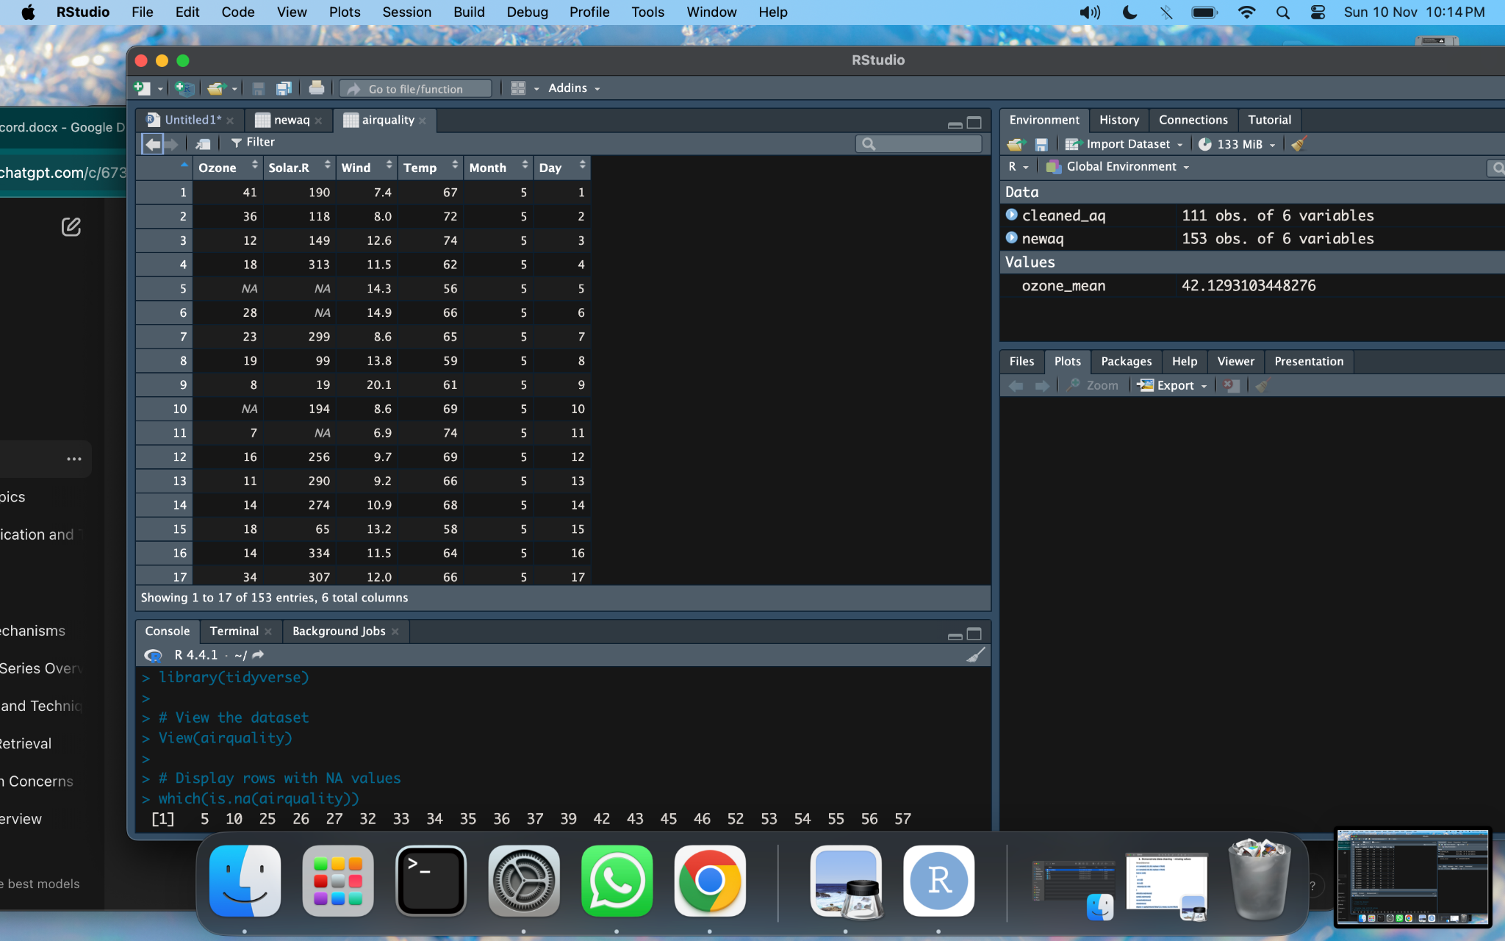

which(is.na(airquality))

sum(is.na(airquality))

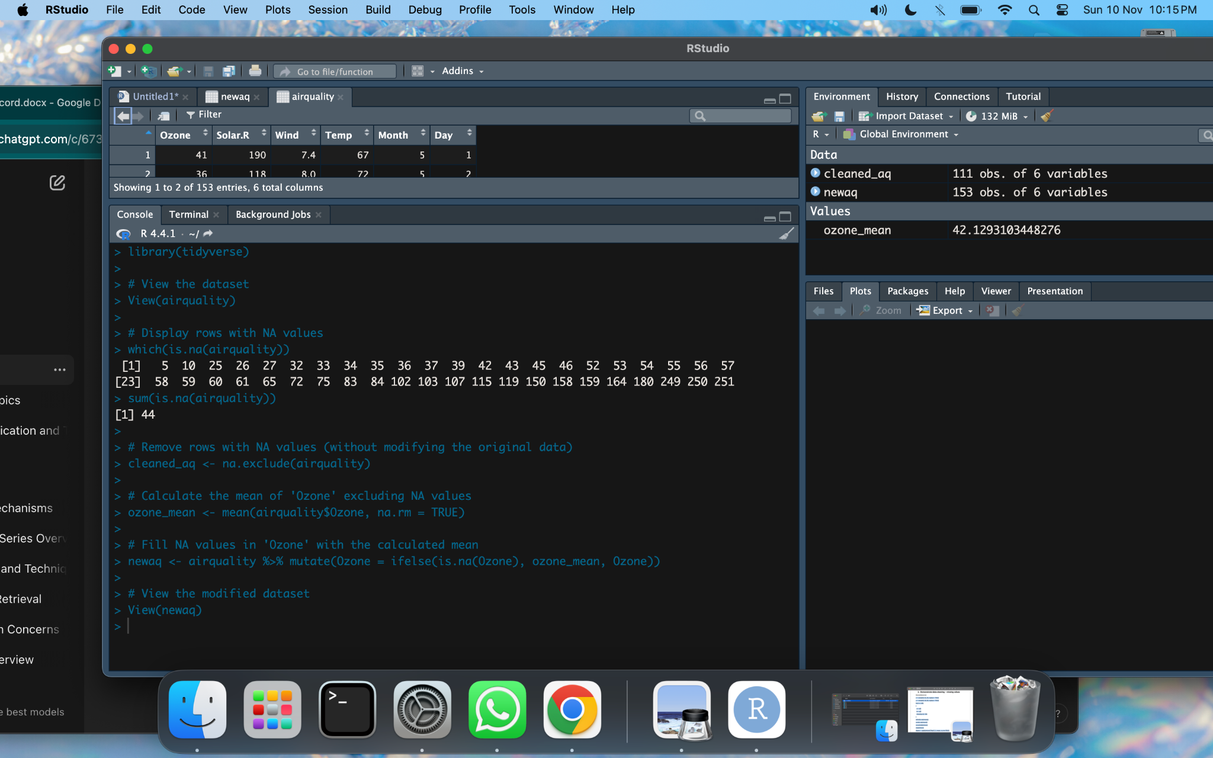

# Remove rows with NA values (without modifying the original data)

cleaned_aq <- na.exclude(airquality)

# Calculate the mean of 'Ozone' excluding NA values

ozone_mean <- mean(airquality$Ozone, na.rm = TRUE)

# Fill NA values in 'Ozone' with the calculated mean

newaq <- airquality %>% mutate(Ozone = ifelse(is.na(Ozone), ozone_mean, Ozone))

# View the modified dataset

View(newaq)

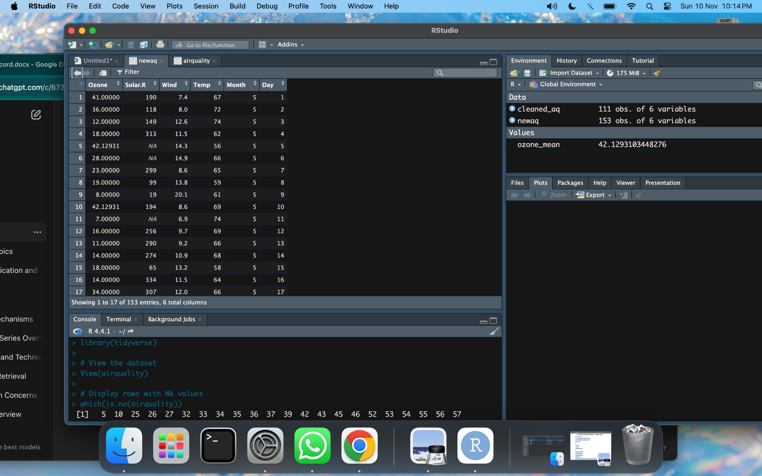

1. **Implement data normalization (min-max, z-score)**

arr <- c(9.5, 6.2, 8.9, 15.2, 20.0, 10.1, 5.4, 3.2, 1.0, 22.5, 10.0, 16.0)

#min-max

minarr <- min(arr)

maxarr <- max(arr)

arr2 <- arr

for (i in 1:12){

arr2[i] = round((arr[i]-minarr)/(maxarr-minarr))

}

print(arr2)

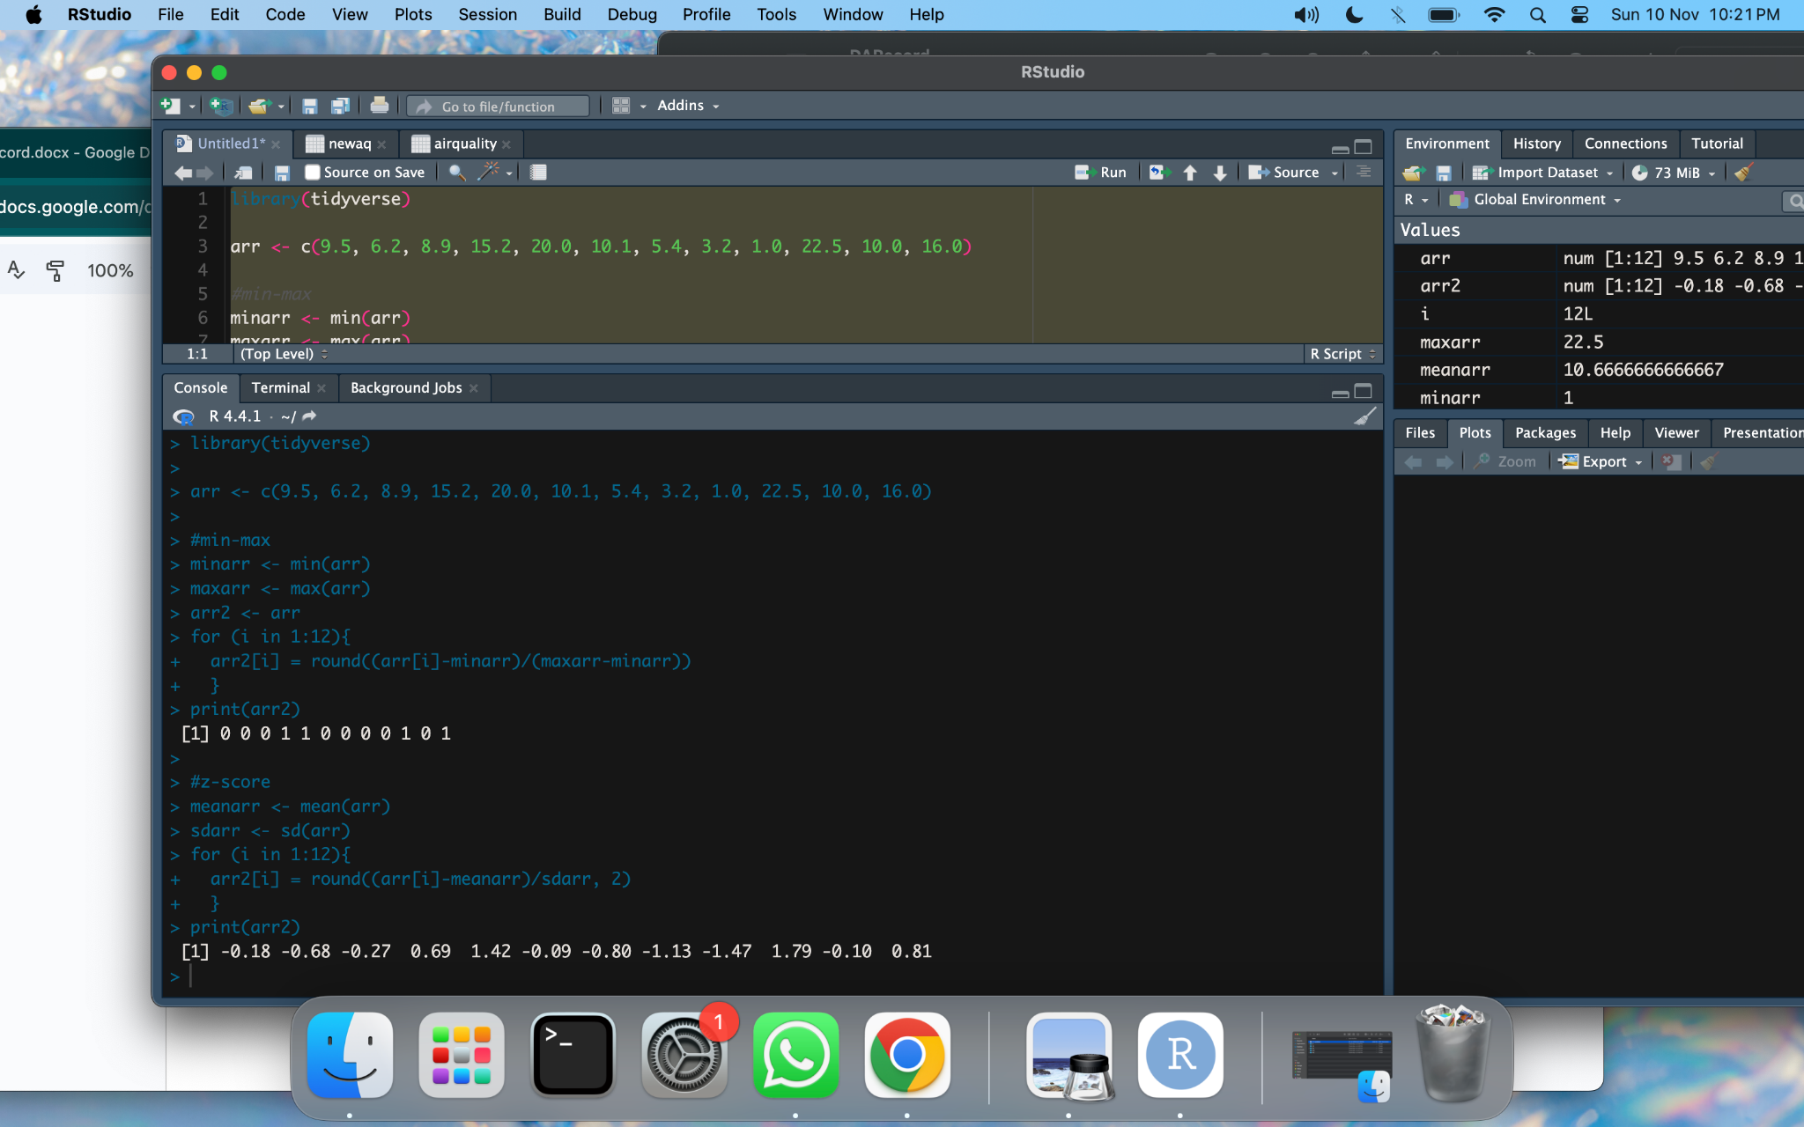

#z-score

meanarr <- mean(arr)

sdarr <- sd(arr)

for (i in 1:12){

arr2[i] = round((arr[i]-meanarr)/sdarr, 2)

}

print(arr2)



1. **Implement attribute subset selection for data reduction**

library(dplyr)

library(leaps)

View(Titanic)

Titanic = Titanic %>% na.omit()

fwd = regsubsets(Freq~., data = Titanic, nvmax = 19, method = "forward")

summary(fwd)

coef(fwd, 3)

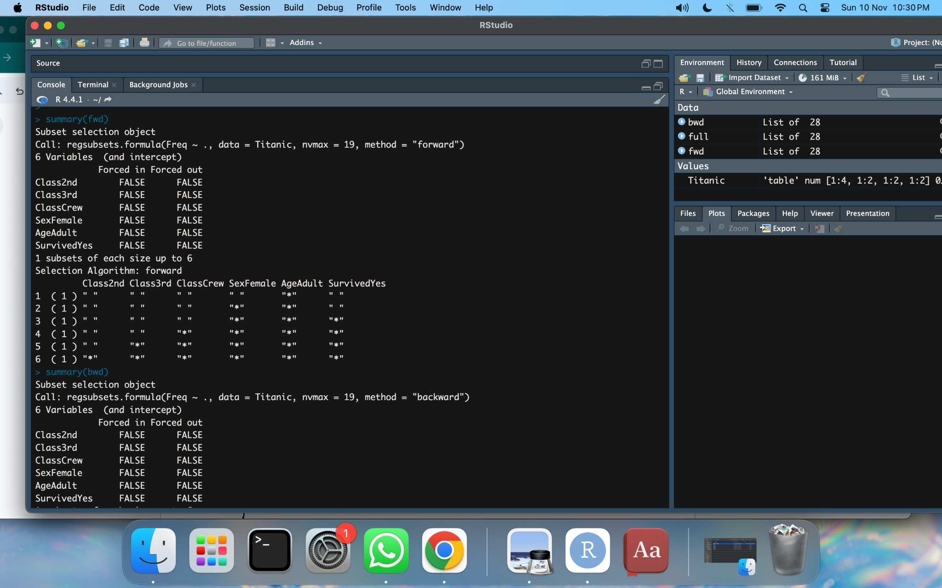

bwd = regsubsets(Freq~., data = Titanic, nvmax = 19, method = "backward")

summary(bwd)

coef(bwd, 3)

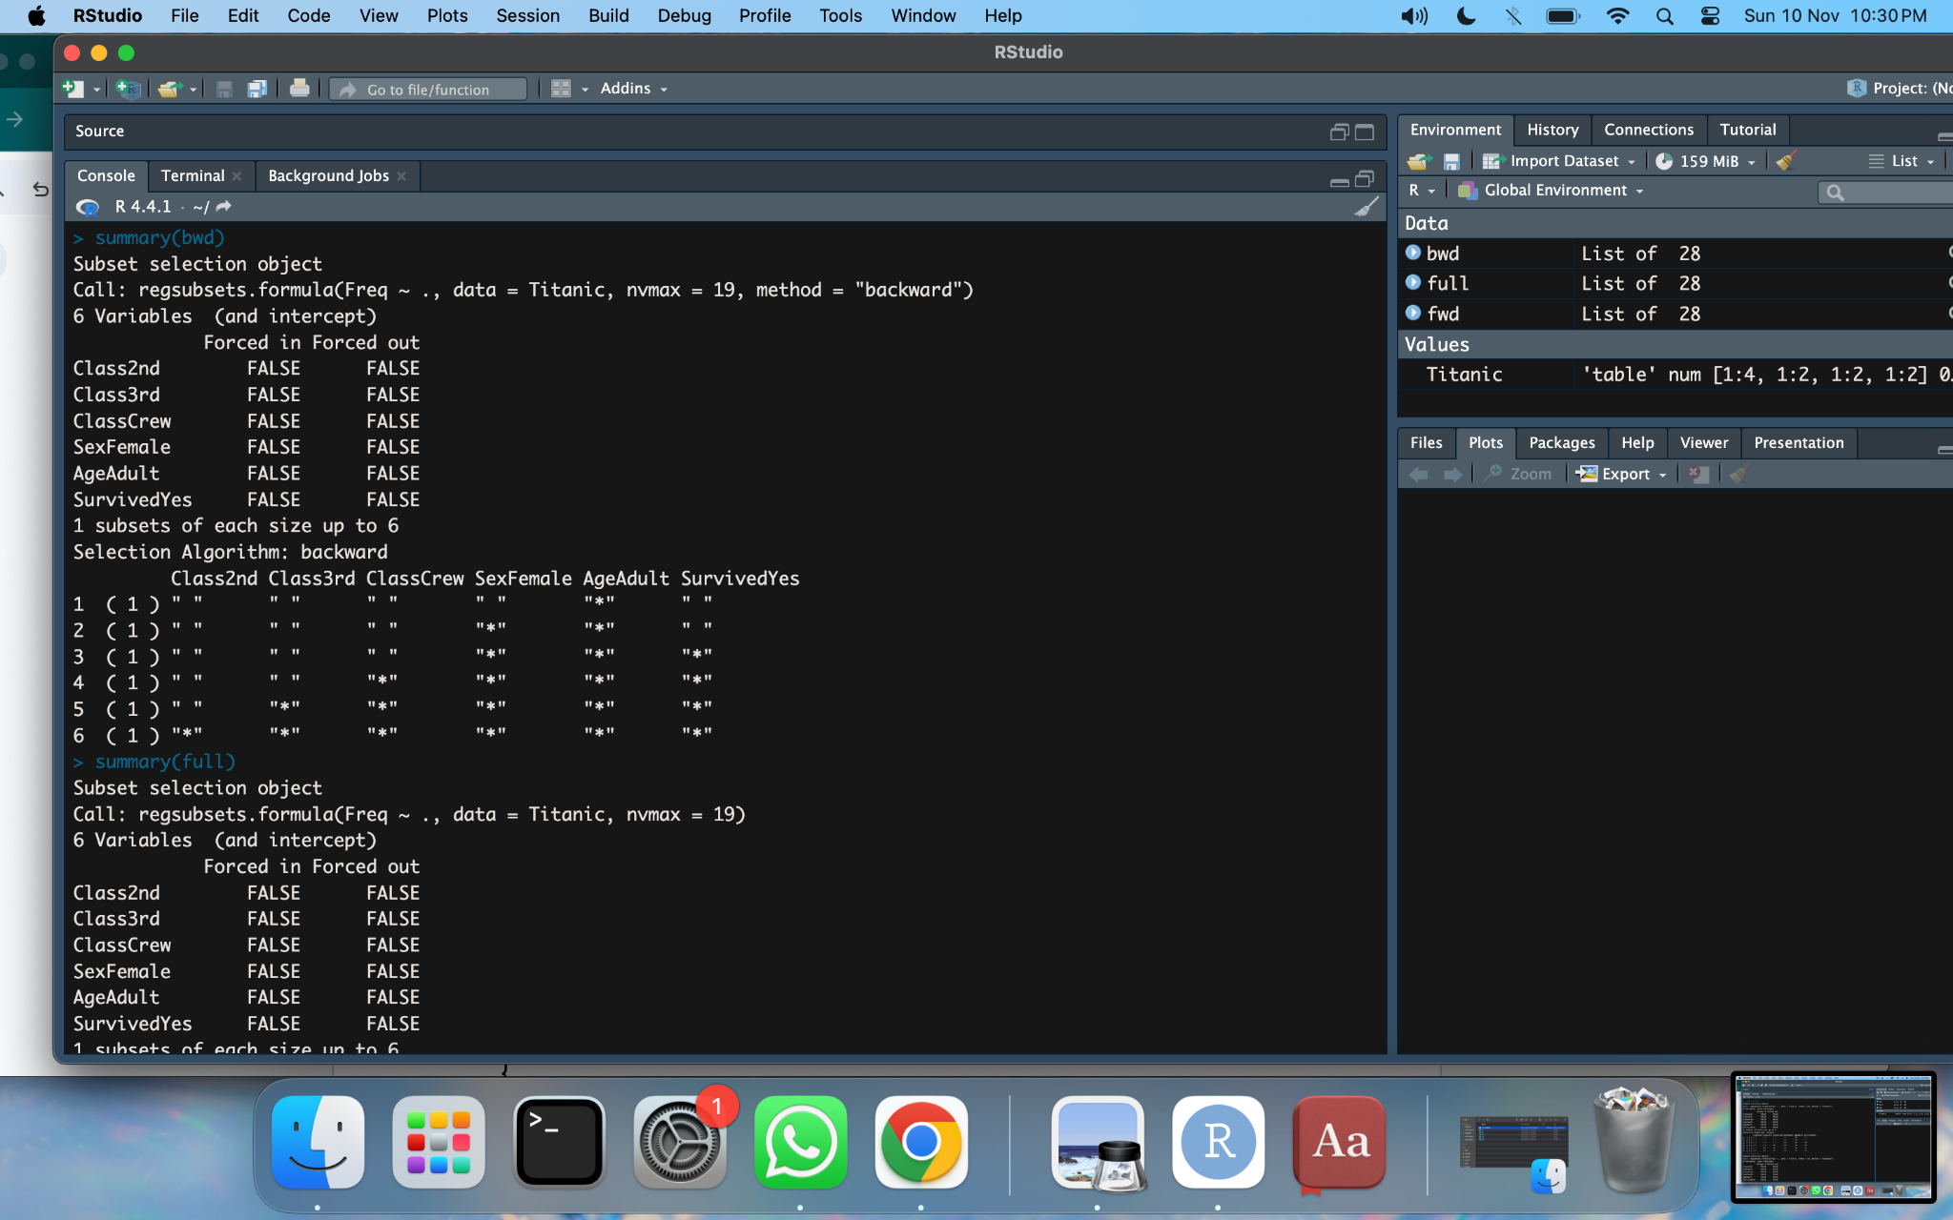

full = regsubsets(Freq~., data = Titanic, nvmax = 19)

summary(full)

coef(full, 3)

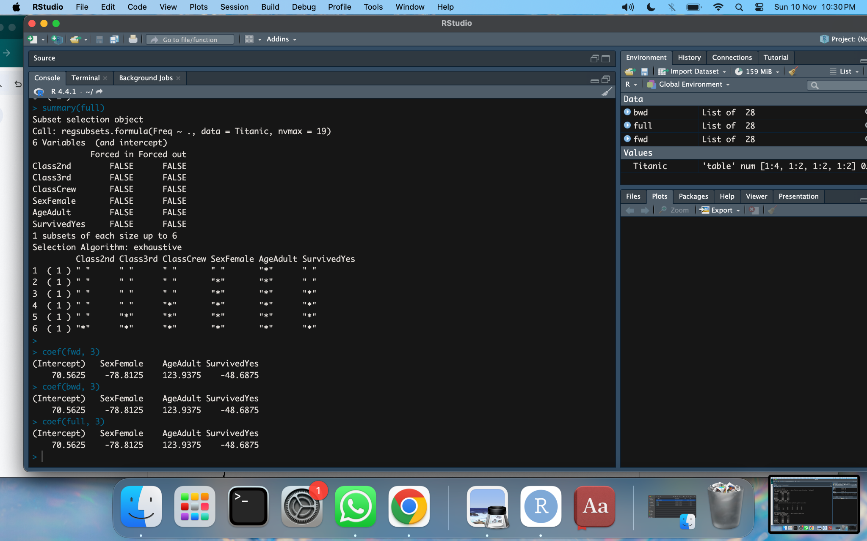

1. **Demonstrate outlier detection**

#download dataset: #<https://archive.ics.uci.edu/dataset/275/bike+sharing+dataset>

file_path<-"/Users/nandinimaharaj/Downloads/bike+sharing+dataset/day.csv"

day<-read.csv(file_path)

View(day)

sum(is.na(day))

boxplot(day[,c("temp","hum","windspeed")])

for(i in c("hum","windspeed"))

{

data<-unlist(day[i])

newData<-data[data %in% boxplot.stats(data)$out]

data[data %in% newData]<-NA

day[i]<-data

}

sum(is.na(data))

day<-na.exclude(day)

boxplot(day[,c("temp","hum","windspeed")])

**OUTPUT:**

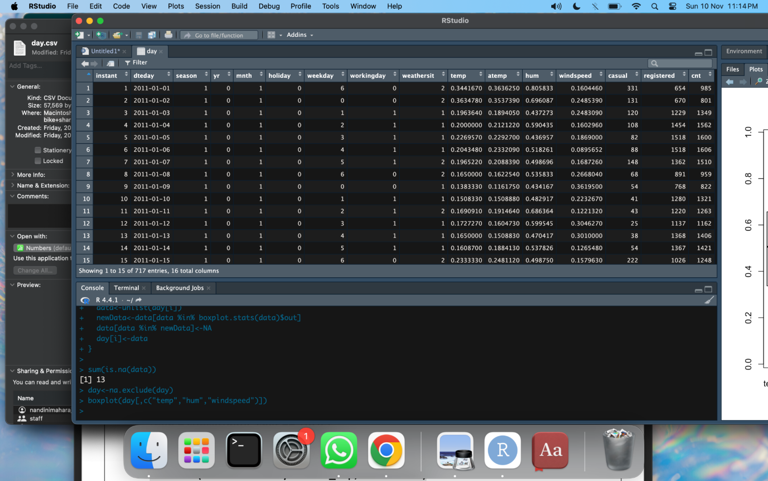

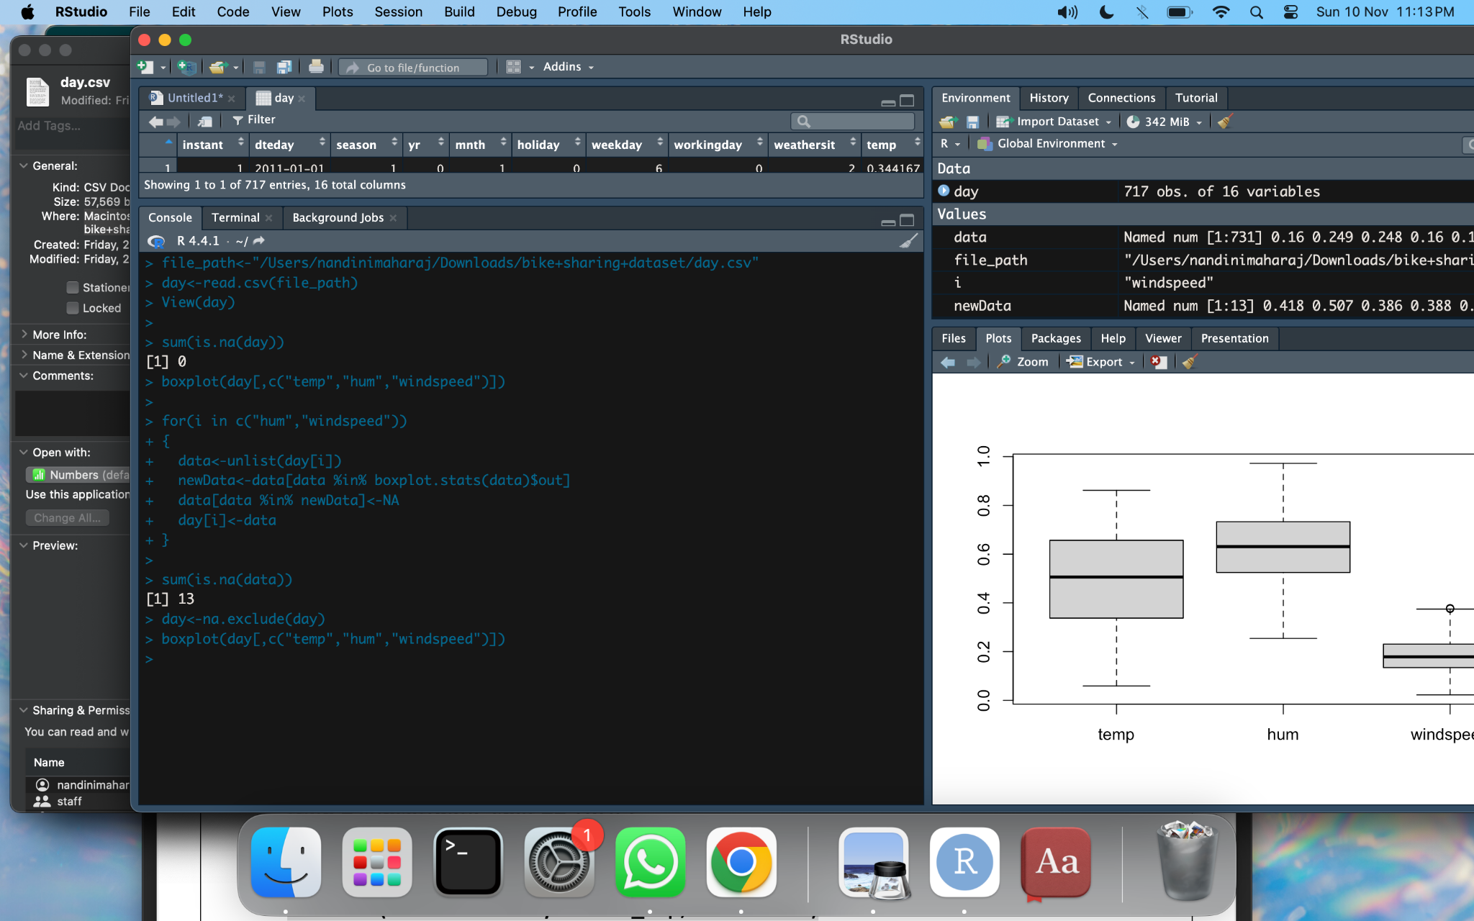

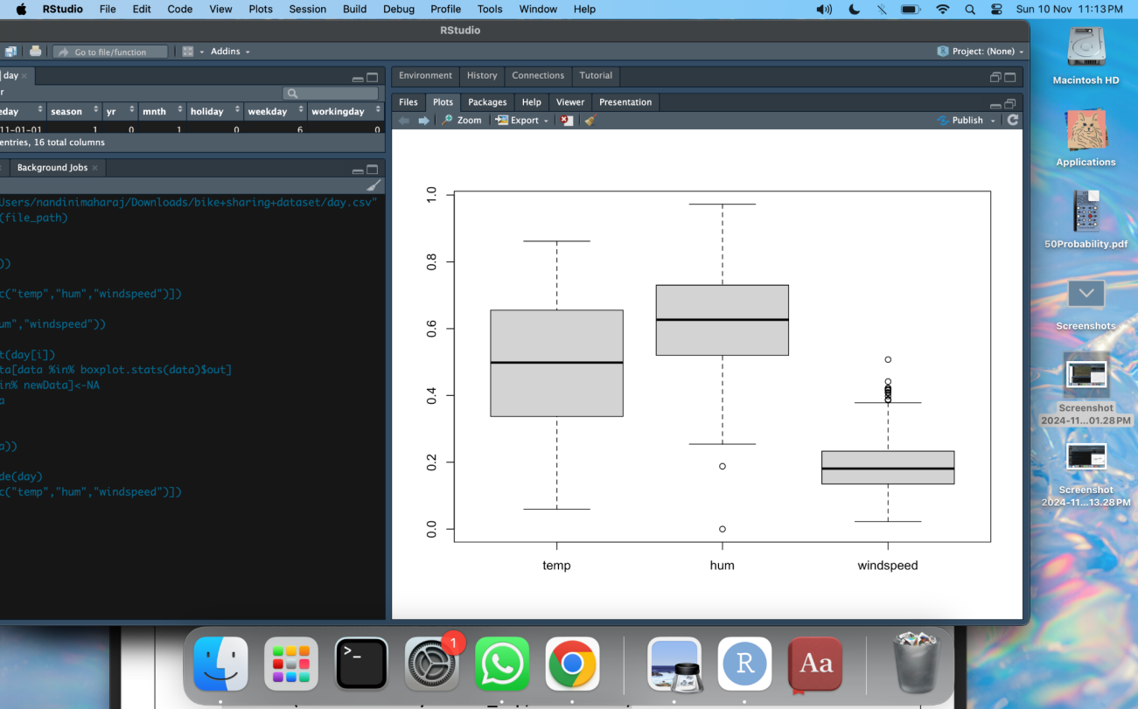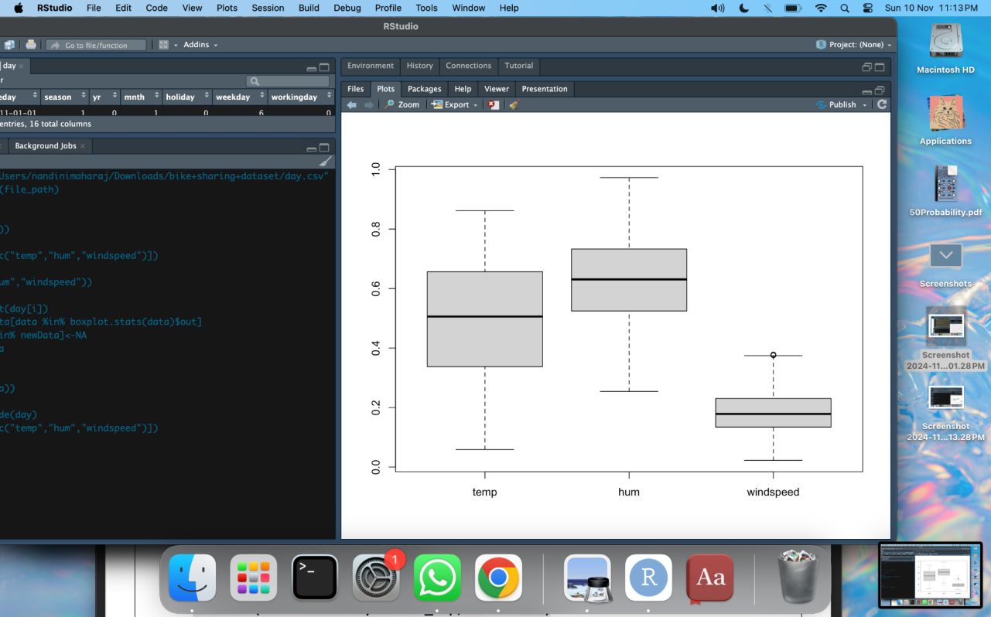

1. **Perform analytics on any standard data set**

#download dataset: #<https://github.com/datasciencedojo/datasets/blob/master/titanic.csv>

titanic <- read.csv("/Users/nandinimaharaj/Downloads/titanic.csv")

library(tidyverse)

head(titanic)

sapply(titanic, class)

#Convert Sex & Survived into factor

titanic$Sex = as.factor(titanic$Sex)

titanic$Survived = as.factor(titanic$Survived)

summary(titanic)

#Filter rows with missing values

dropnull_titanic = titanic[rowSums(is.na(titanic)) <= 0, ]

#Splitting based on survival

survivedList = dropnull_titanic[dropnull_titanic$Survived == 1 , ]

notSurvivedList = dropnull_titanic[dropnull_titanic$Survived == 0, ]

#Pie chart of Survived & Not Survived

mytable <- table(titanic$Survived)

lbls <- c("Not Survived","Survived")

pie(

mytable,

labels = lbls,

main = "pie chart"

)

#Histogram of Ages

hist(titanic$Age, xlab = "gender", ylab = "frequency")

#Bar plot of Gender Distribution among Non-Survivors

barplot(table(notSurvivedList$Sex), xlab = "gender", ylab = "frequency")

#Density plot of fare of Survivors

temp <- density(table(survivedList$Fare))

plot(temp, type = "n", main = "fare charged")

polygon(temp, col = "lightgray", border = "gray")

#Box plot of Fare

boxplot(titanic$Fare, main = "fare")

**OUTPUT:**

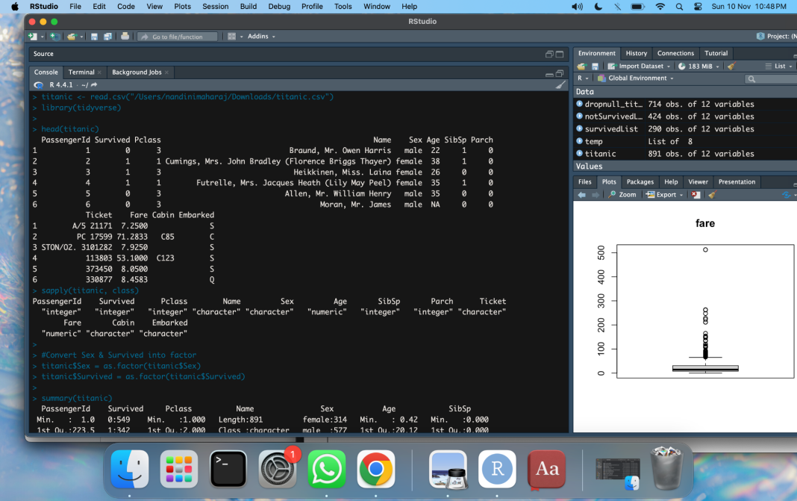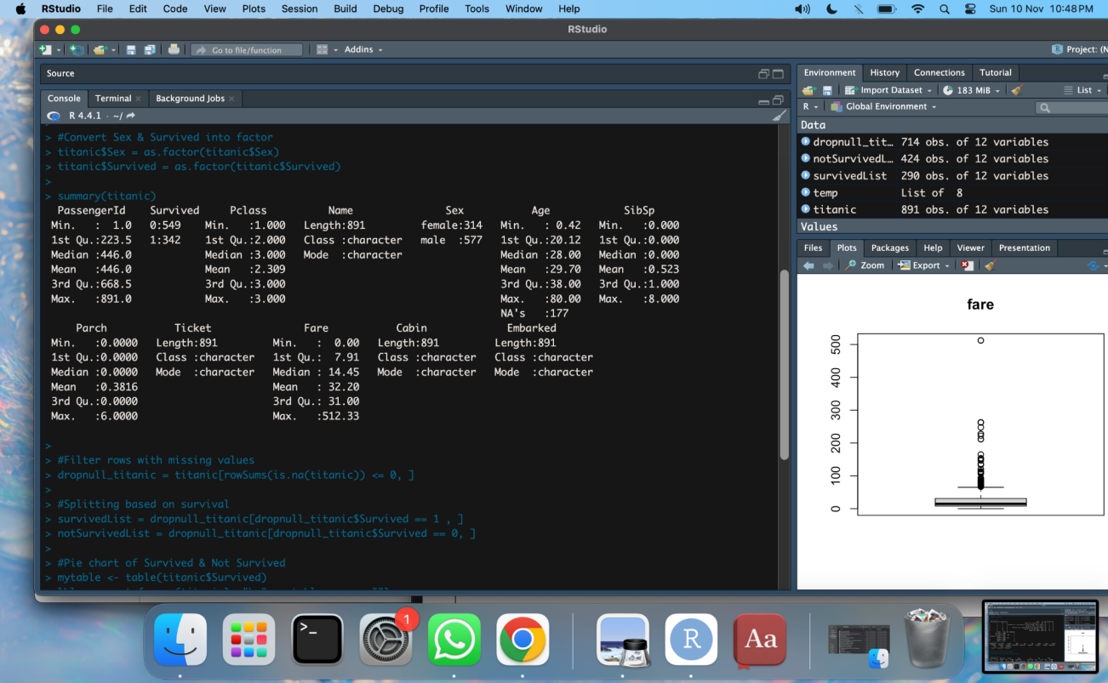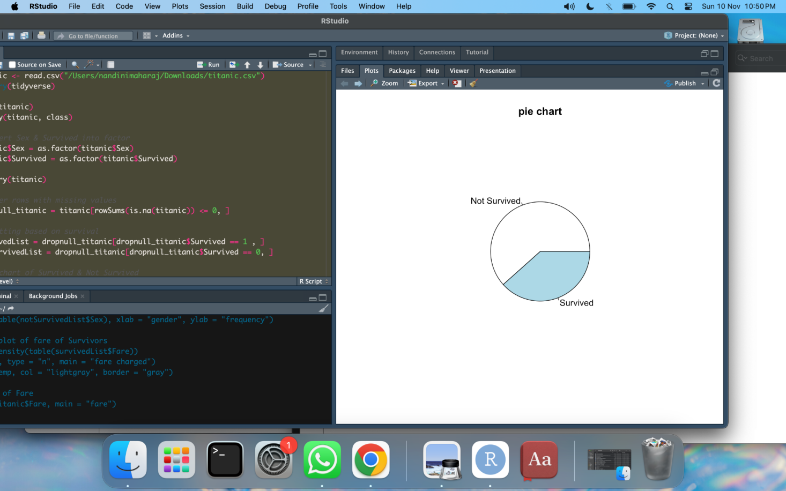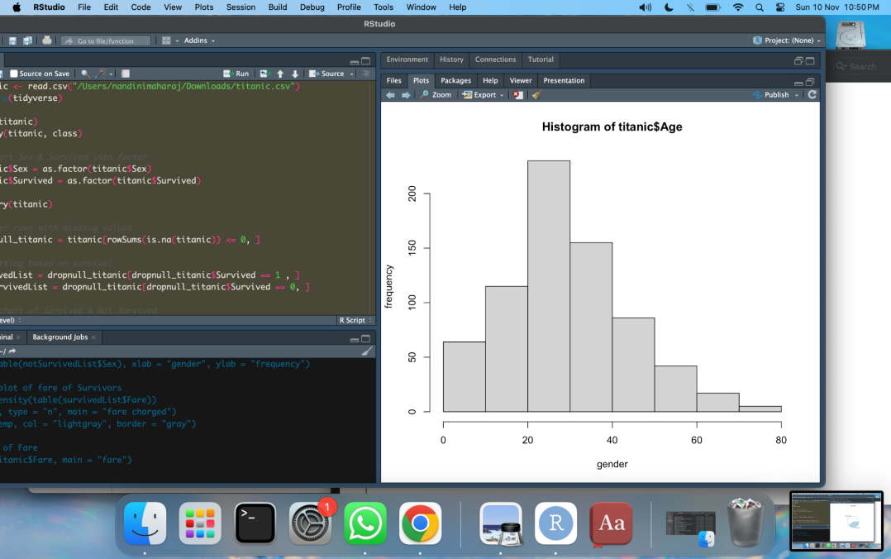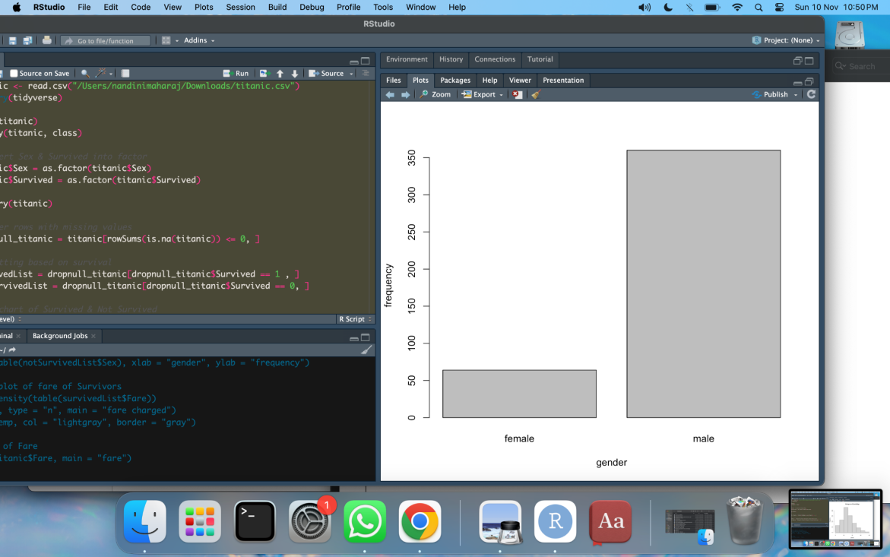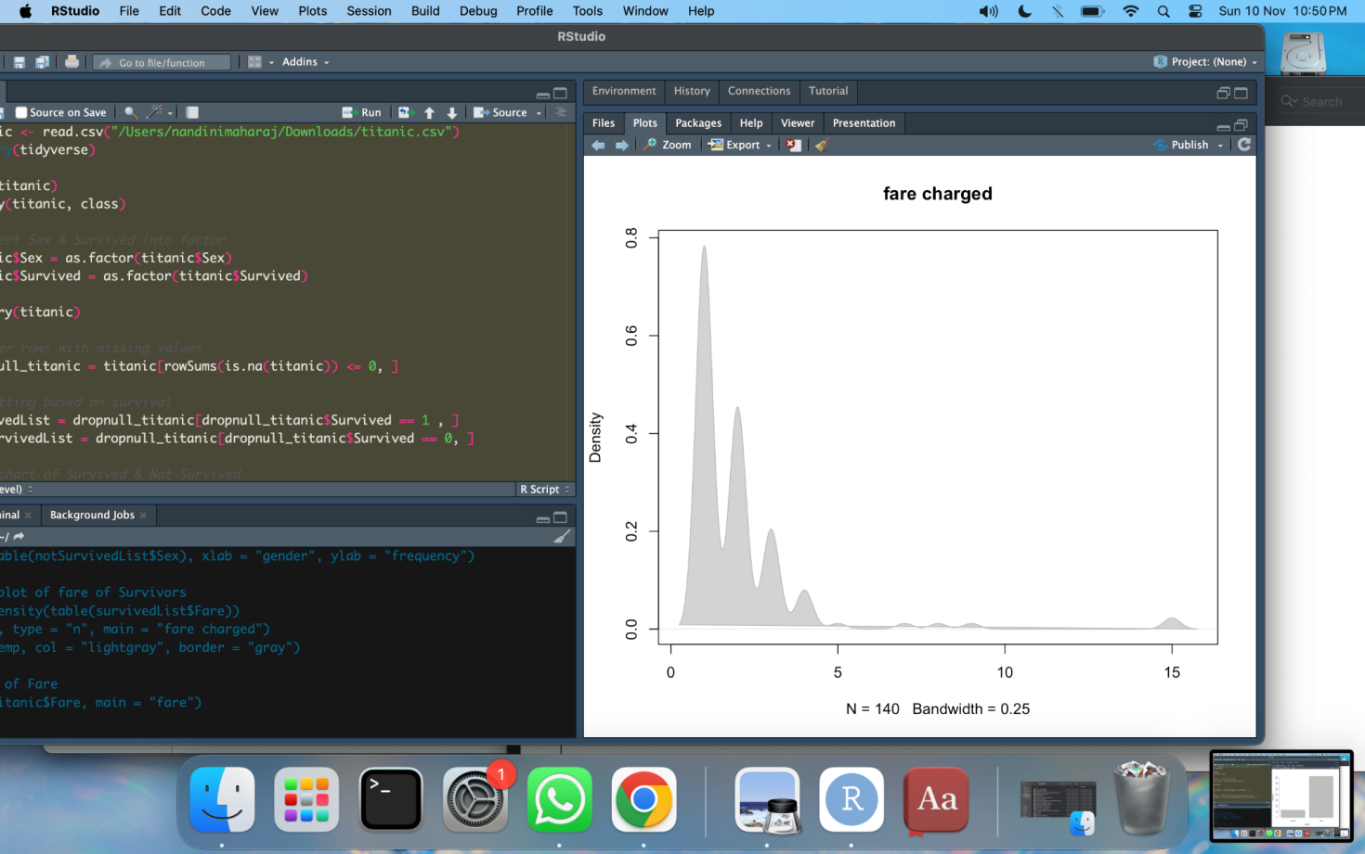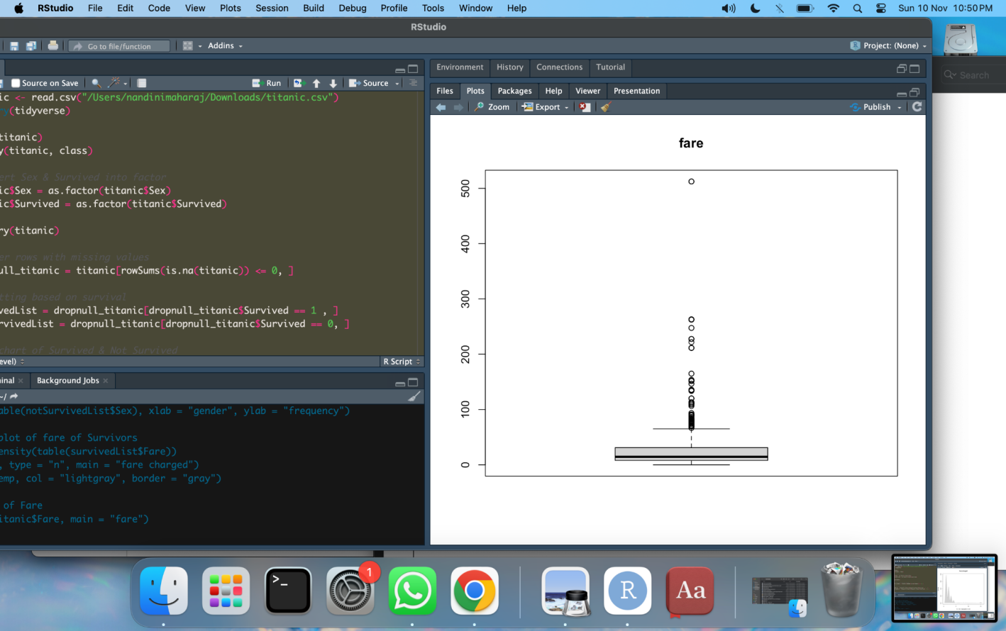

1. **Implement linear regression**

library(caTools)

data <- data.frame(

Years_Exp = c(1.1, 1.3, 1.5, 2.0, 2.2, 2.9, 3.0, 3.2, 3.2, 3.7),

Salary = c(39343.00, 46205.00, 37731.00, 43525.00, 39891.00, 56642.00, 60150.00, 54445.00, 64445.00, 57189.00))

split = sample.split(data$Salary, SplitRatio = 0.7)

train = subset(data, split == TRUE)

test = subset(data, split == FALSE)

lm.r = lm(formula = Salary ~ Years_Exp, data = train)

coef(lm.r)

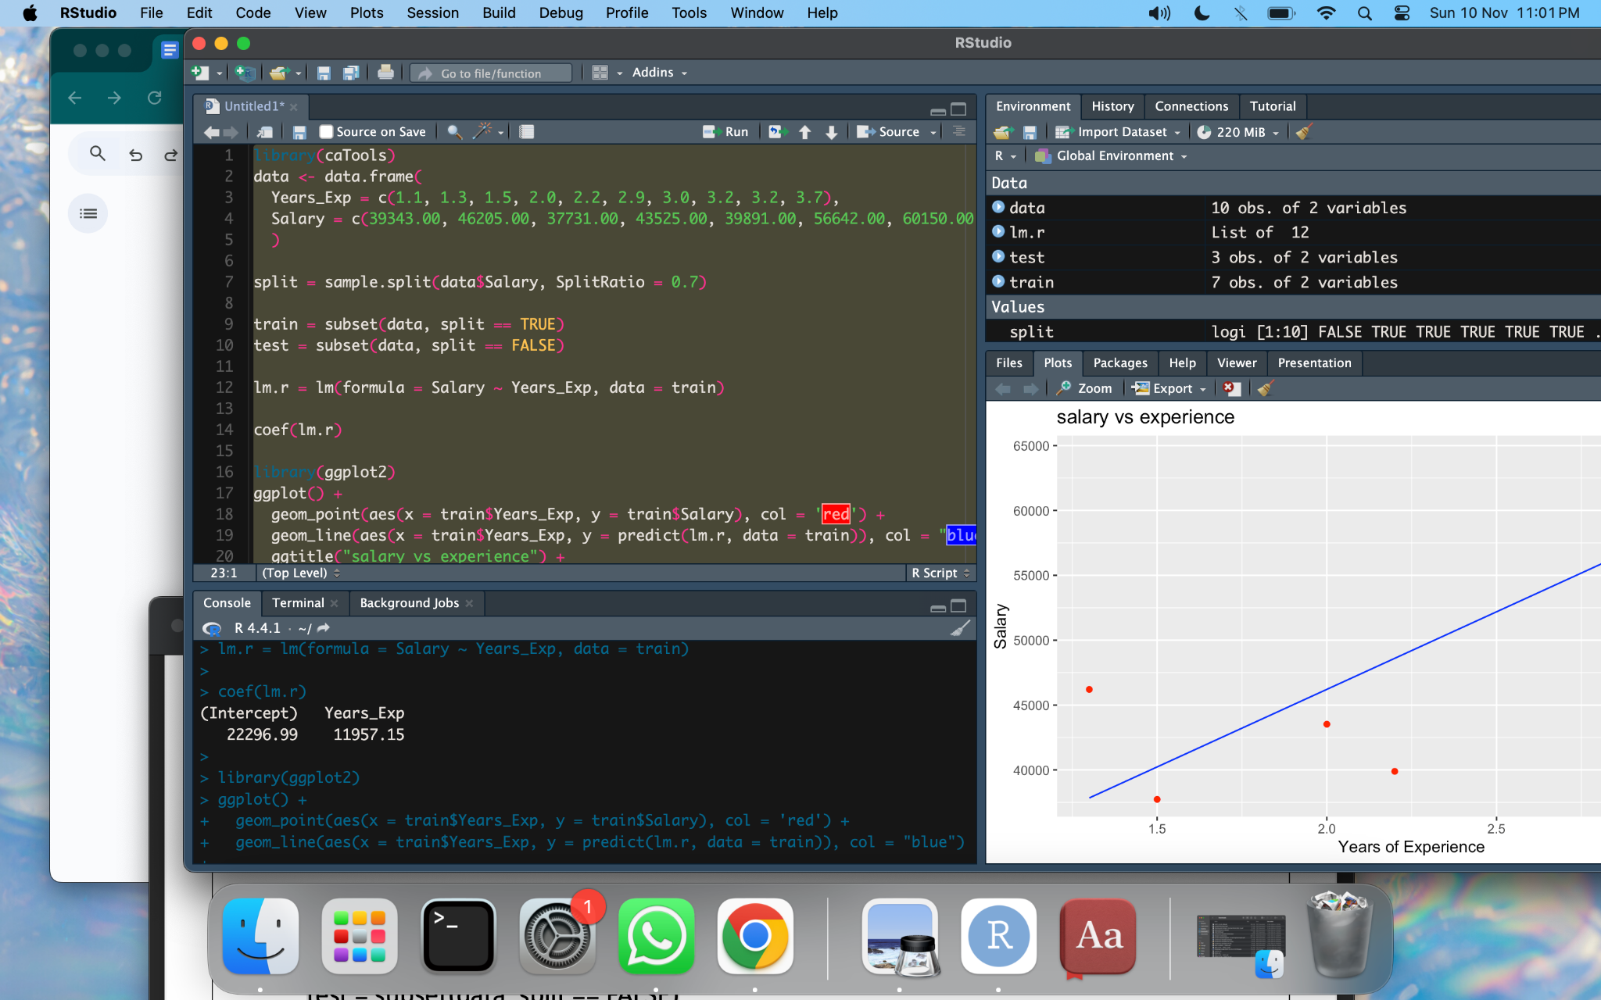

library(ggplot2)

ggplot() +

geom_point(aes(x = train$Years_Exp, y = train$Salary), col = 'red') +

geom_line(aes(x = train$Years_Exp, y = predict(lm.r, data = train)), col = "blue") +

ggtitle("salary vs experience") +

xlab("Years of Experience") +

ylab("Salary")

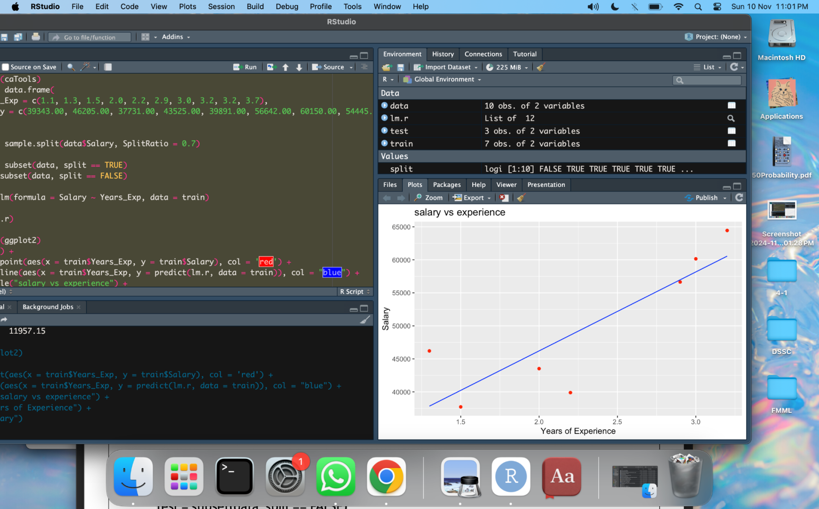

# Predict salaries on the test set

test_predictions <- predict(lm.r, newdata = test)

# Calculate Mean Absolute Error (MAE)

mae <- mean(abs(test$Salary - test_predictions))

print(paste("Mean Absolute Error (MAE):", mae))



1. **Implement logistic regression**

# Load necessary libraries

install.packages("pROC")

library(ggplot2)

library(pROC)

# Load the iris dataset

data(iris)

# Convert the Species column to a binary outcome (Setosa vs. Non-Setosa)

iris$SpeciesBinary <- ifelse(iris$Species == "setosa", 1, 0)

# Logistic regression model: Predict if the flower is Setosa based on Sepal.Length

logistic_model <- glm(SpeciesBinary ~ Sepal.Length, data = iris, family = "binomial")

# View the summary of the logistic regression model

summary(logistic_model)

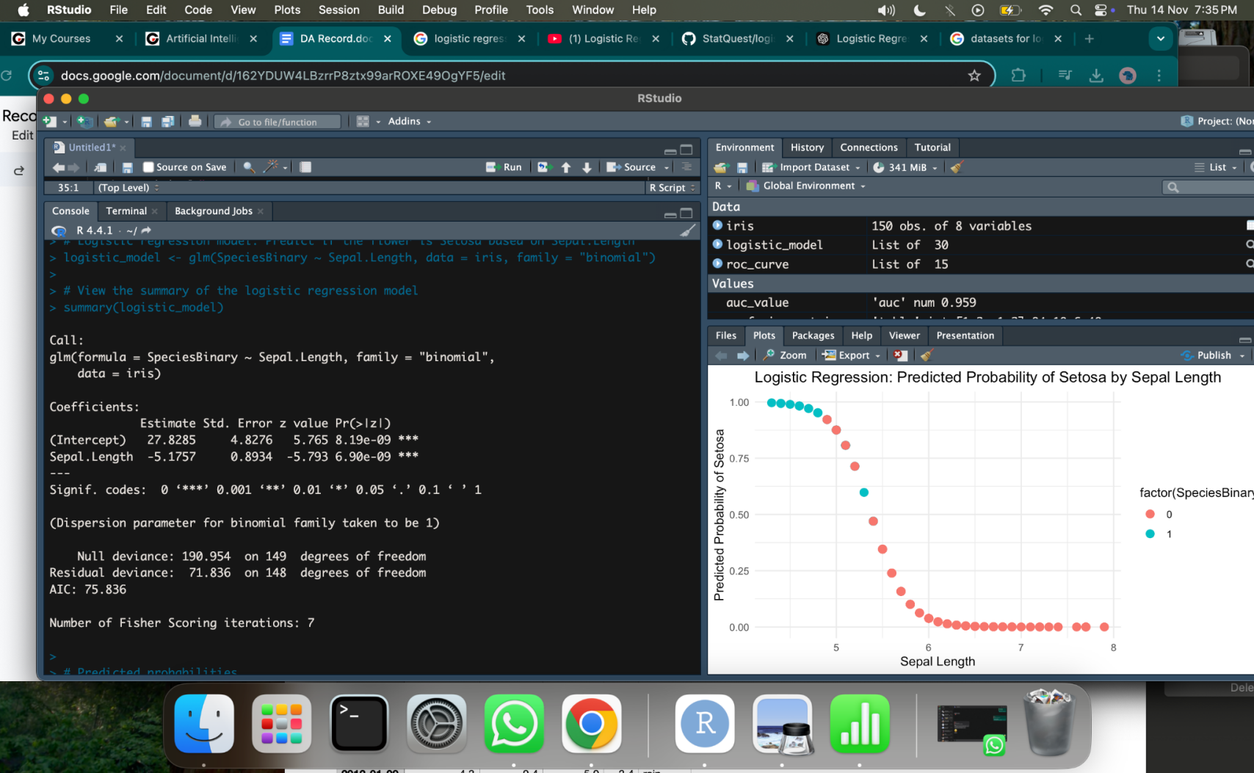

# Predicted probabilities

iris$predicted_probabilities <- predict(logistic_model, type = "response")

# Add a column for predicted class (0 or 1) based on threshold of 0.5

iris$predicted_class <- ifelse(iris$predicted_probabilities > 0.5, 1, 0)

# Create a confusion matrix

confusion_matrix <- table(Actual = iris$SpeciesBinary, Predicted = iris$predicted_class)

print(confusion_matrix)

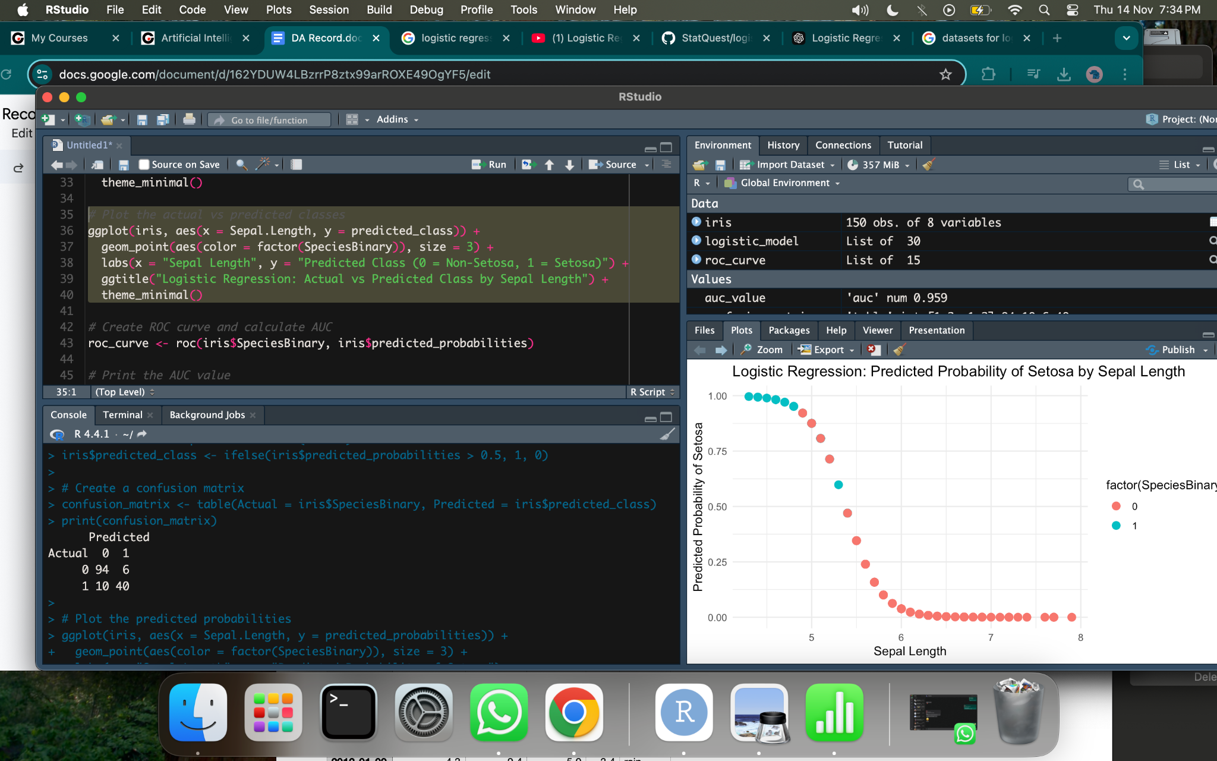

# Plot the predicted probabilities

ggplot(iris, aes(x = Sepal.Length, y = predicted_probabilities)) +

geom_point(aes(color = factor(SpeciesBinary)), size = 3) +

labs(x = "Sepal Length", y = "Predicted Probability of Setosa") +

ggtitle("Logistic Regression: Predicted Probability of Setosa by Sepal Length") +

theme_minimal()

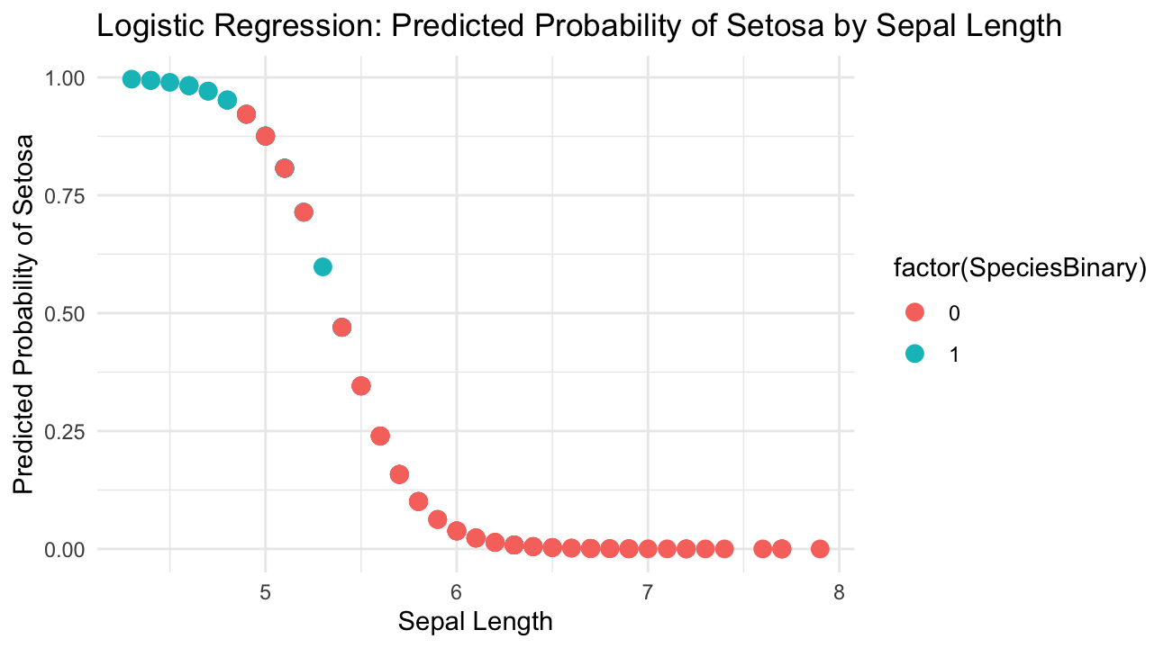

# Create ROC curve and calculate AUC

roc_curve <- roc(iris$SpeciesBinary, iris$predicted_probabilities)

# Print the AUC value

auc_value <- auc(roc_curve)

print(paste("AUC:", auc_value))



# Plot the ROC curve

plot(roc_curve, main = paste("ROC Curve (AUC =", round(auc_value, 2), ")"), col = "blue", lwd = 2)

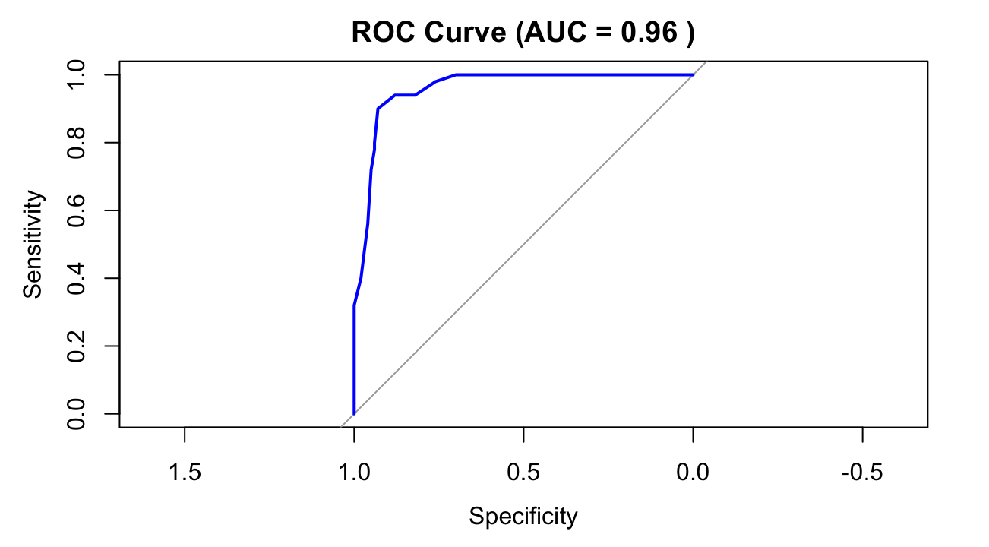

1. **Construct decision tree for weather data set**

install.packages("partykit")

# Load necessary libraries

library(tidyverse)

library(partykit)

library(caTools)

# download & load dataset:

#<https://www.kaggle.com/datasets/petalme/seattle-weather-prediction-dataset>

weatherdata <- read.csv("/Users/nandinimaharaj/Downloads/seattle-weather.csv")

# Inspect the dataset

head(weatherdata)

str(weatherdata)

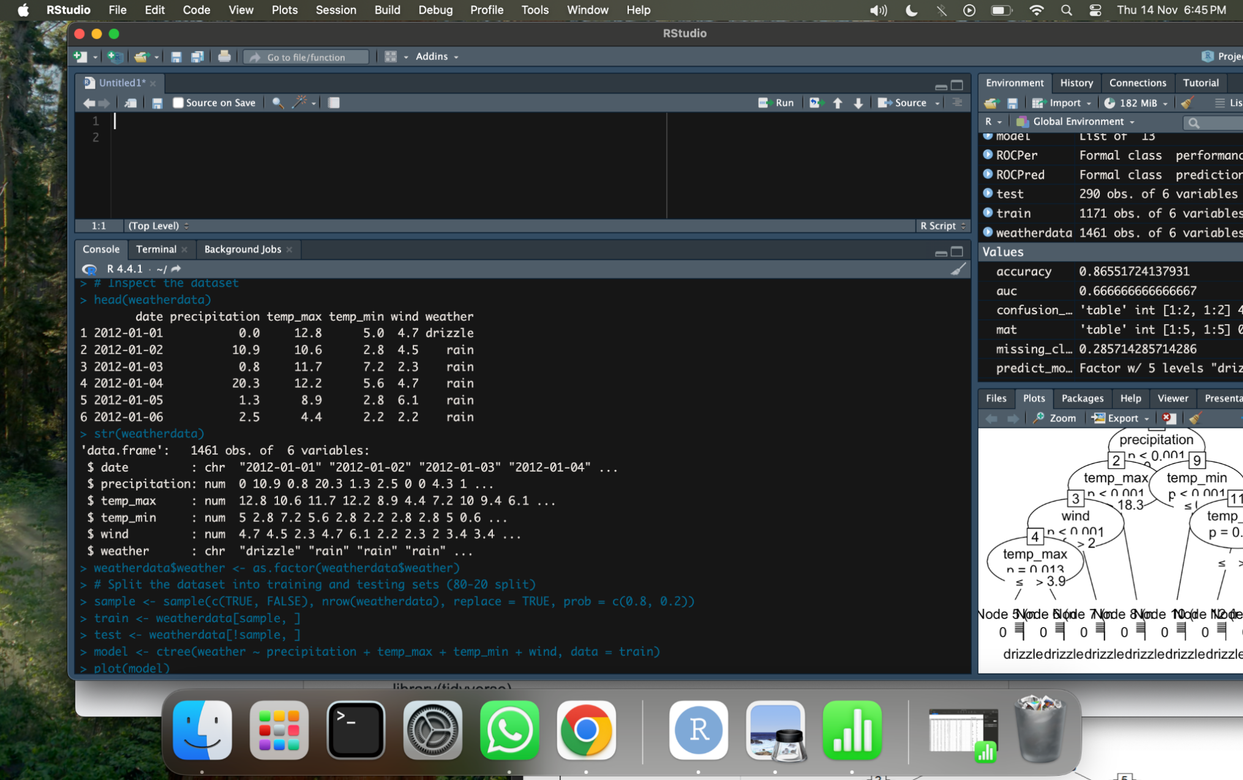

# Convert 'weather' to a factor for classification

weatherdata$weather <- as.factor(weatherdata$weather)

# Split the dataset into training and testing sets (80-20 split)

split=sample.split(weatherdata$weather, SplitRatio=0.8)

train=subset(weatherdata, split==TRUE)

test=subset(weatherdata, split==FALSE)

# Train a decision tree model to predict 'weather'

model <- ctree(weather ~ precipitation + temp_max + temp_min + wind, data = train)

# Plot the decision tree

plot(model)

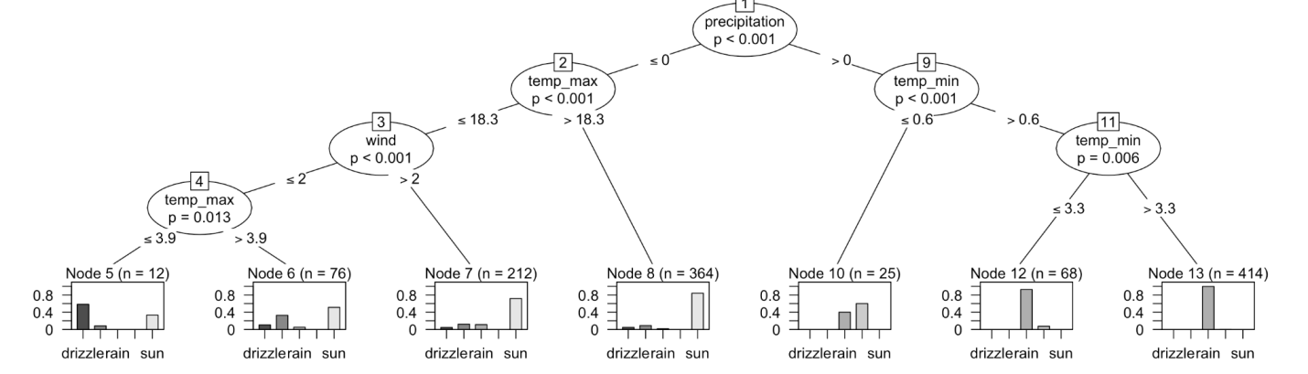

# Make predictions on the test set

predict_model <- predict(model, test)

# Generate a confusion matrix to evaluate model performance

mat <- table(test$weather, predict_model)

print(mat)

# Calculate the accuracy of the model

accuracy <- sum(diag(mat)) / sum(mat)

print(paste("Accuracy:", accuracy))

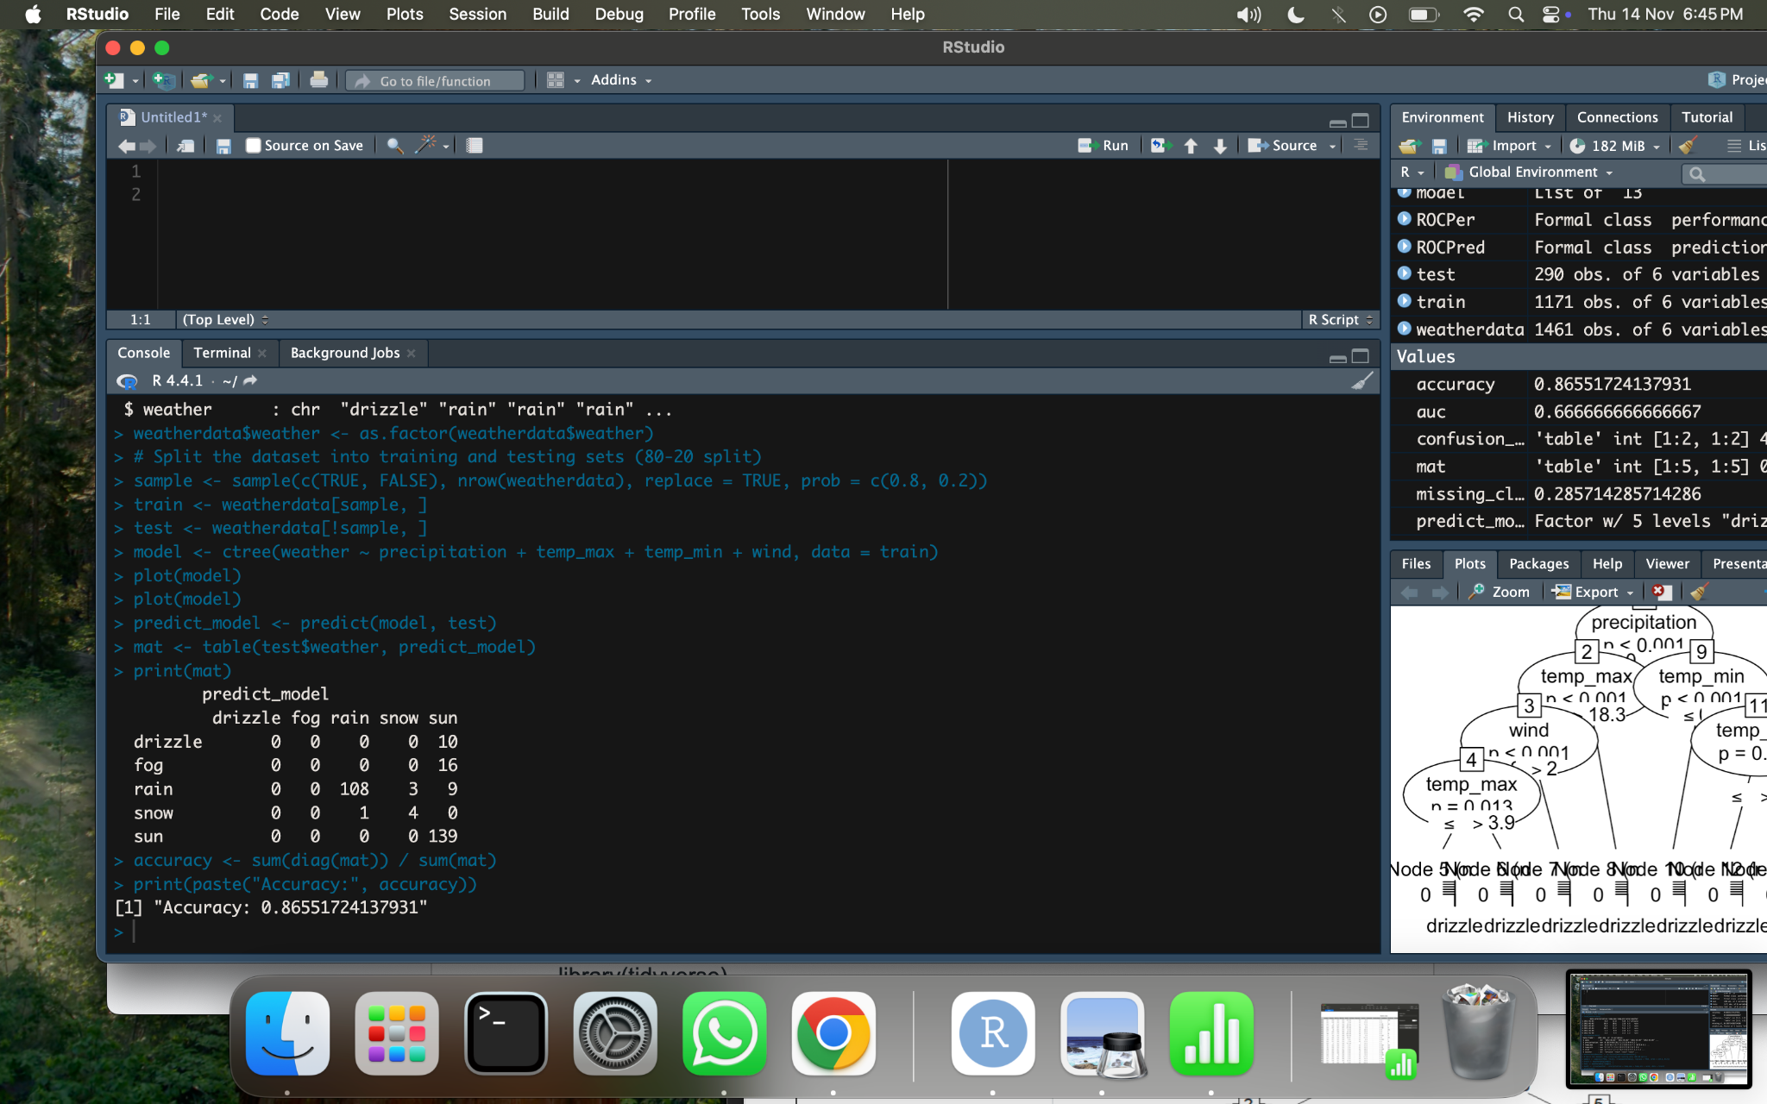

1. **Analyze time-series data**

# Load necessary libraries

library(lubridate) #converts the starting date into a decimal date

library(forecast) #use it to fit ARIMA models and make forecasts

# Data for positive cases and deaths (as weekly counts)

positiveCases <- c(580, 7813, 28266, 59287, 75700, 87820, 95314, 126214, 218843, 471497, 936851, 1508725, 2072113)

deaths <- c(17, 270, 565, 1261, 2126, 2800, 3285, 4628, 8951, 21283, 47210, 88480, 138475)

# Create a multivariate time series object

# Starting from January 22, 2020, with weekly frequency

mts <- ts(cbind(positiveCases, deaths),

start = decimal_date(ymd("2020-01-22")), # Date conversion to decimal format

frequency = 365.25 / 7) # Approximate weekly frequency

# Plot the multivariate time series data (positive cases and deaths)

plot(mts,

xlab = "Weekly Data",

main = "COVID-19 Cases",

col.main = "darkgreen")

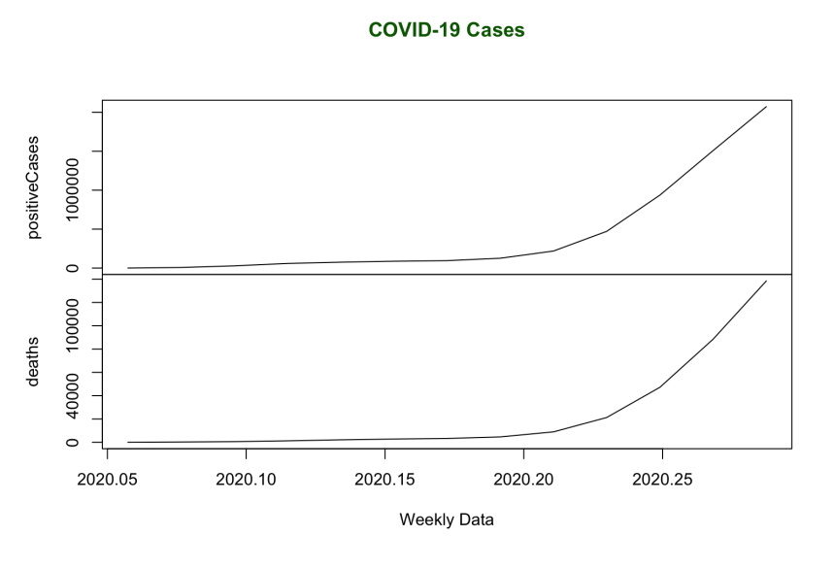

# Create a time series object for positive cases alone

mts1 <- ts(positiveCases,

start = decimal_date(ymd("2020-01-22")),

frequency = 365.25 / 7) # Weekly frequency

# Fit an ARIMA model to the positive cases time series

fit <- auto.arima(mts1)

# Generate forecasts for the next 5 periods (weeks)

fit_forecast <- forecast(fit, h = 5)

# Plot the forecast of positive cases for the next 5 weeks

plot(fit_forecast,

xlab = "Weekly Data",

ylab = "Positive Cases",

main = "COVID-19 Forecast",

col.main = "green")

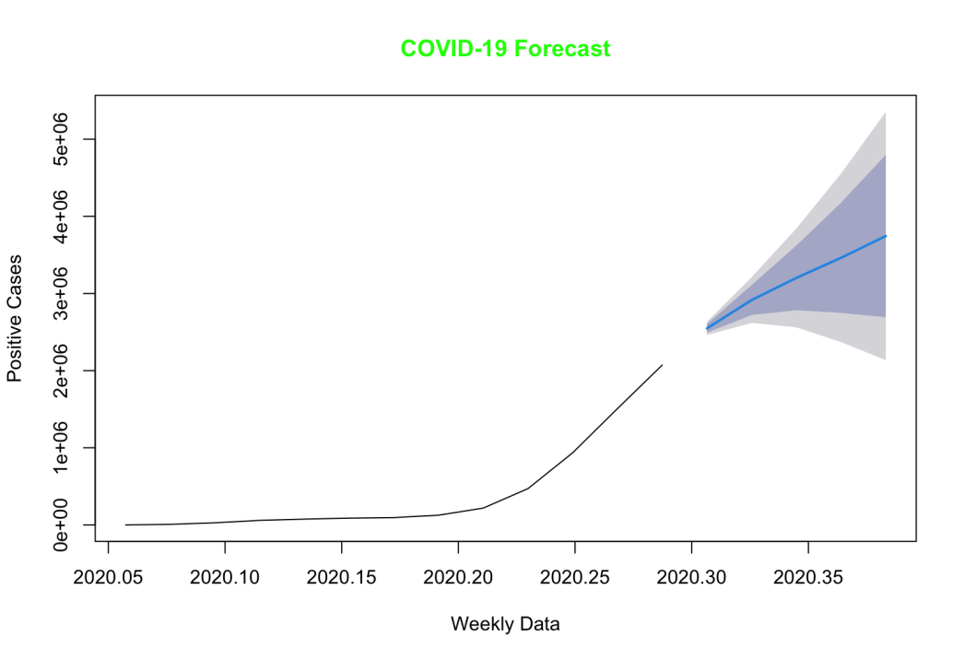

1. **Work on any data visualization tool**

view(airquality)

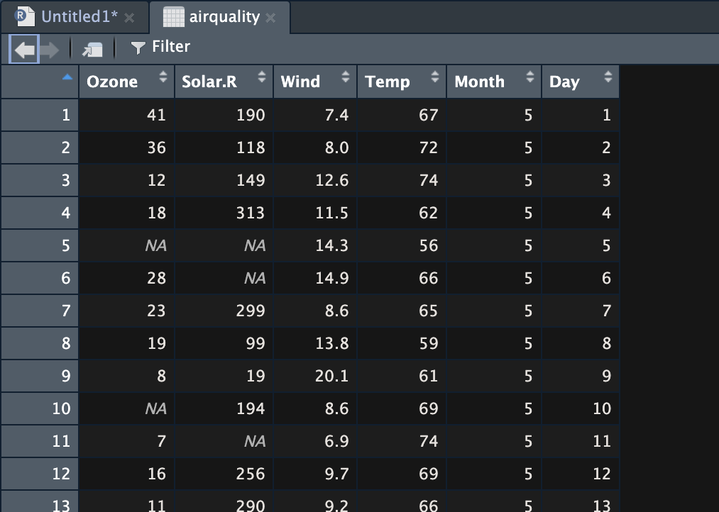

# Bar plot for Ozone concentration

barplot(

airquality$Ozone,

main = "Ozone Concentration in Air",

xlab = "Ozone Levels",

horiz = TRUE

)

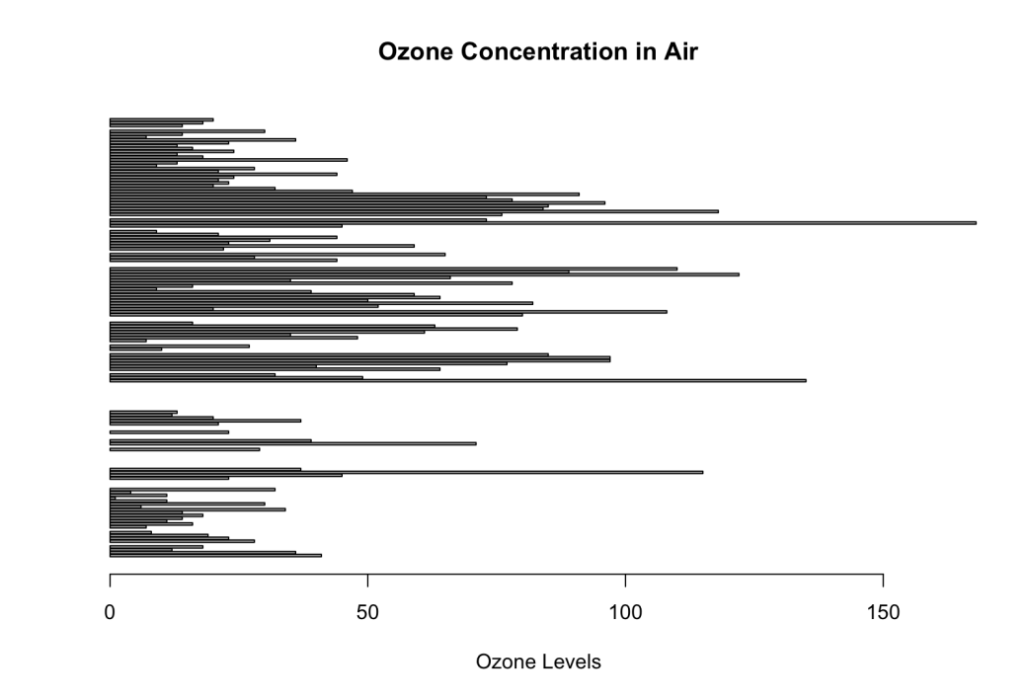

# Histogram of Temperature at La Guardia Airport

hist(

airquality$Temp,

main = "La Guardia Airport's Maximum Temperature (Daily)",

xlab = "Temperature (Fahrenheit)",

xlim = c(50, 125),

col = "yellow",

freq = TRUE

)

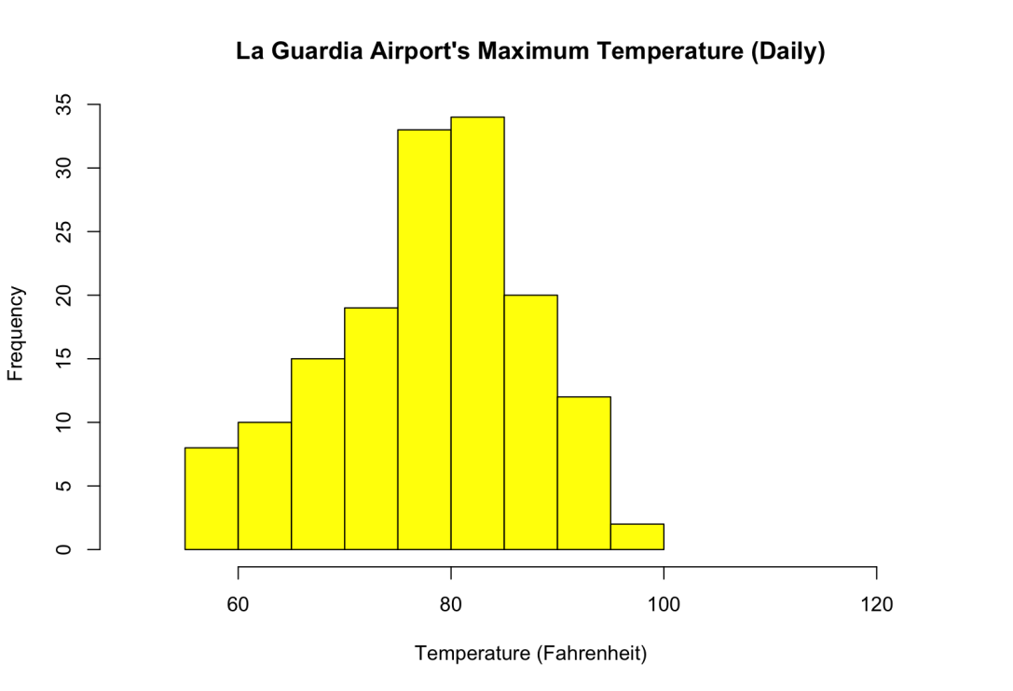

# Box plots for selected air quality parameters

boxplot(

airquality[, 1:4],

main = "Box Plots for Air Quality Parameters"

)

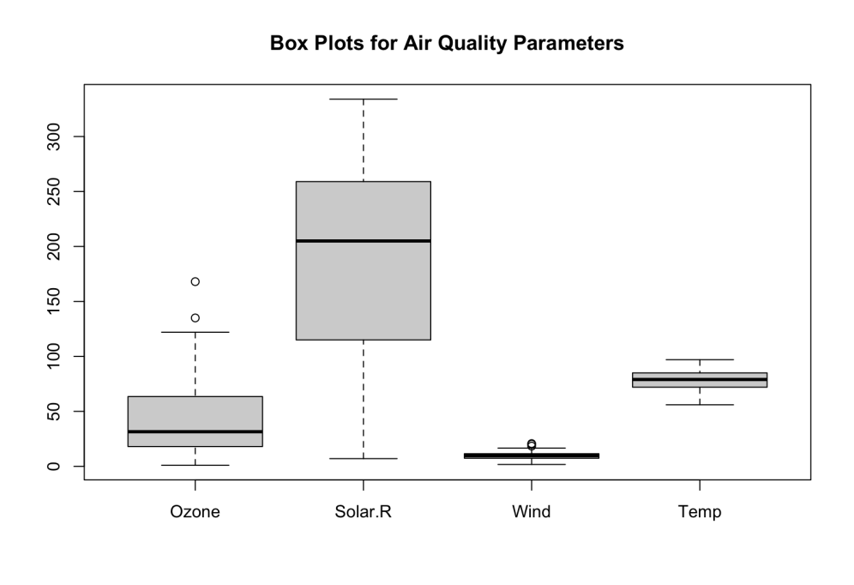

# Scatter plot for Ozone concentration by Month

plot(

airquality$Ozone,

airquality$Month,

main = "Scatterplot of Ozone Concentration by Month",

xlab = "Ozone Concentration (ppb)",

ylab = "Month of Observation",

pch = 19

)

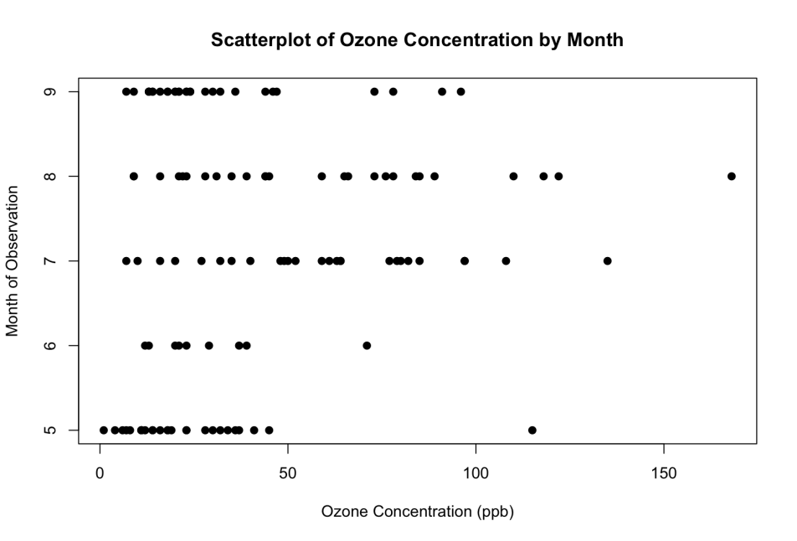

# Creating a sample matrix and drawing a heatmap

data <- matrix(rnorm(25, 0, 5), nrow = 5, ncol = 5)

colnames(data) <- paste("Col", 1:5)

rownames(data) <- paste("Row", 1:5)

heatmap(data)

